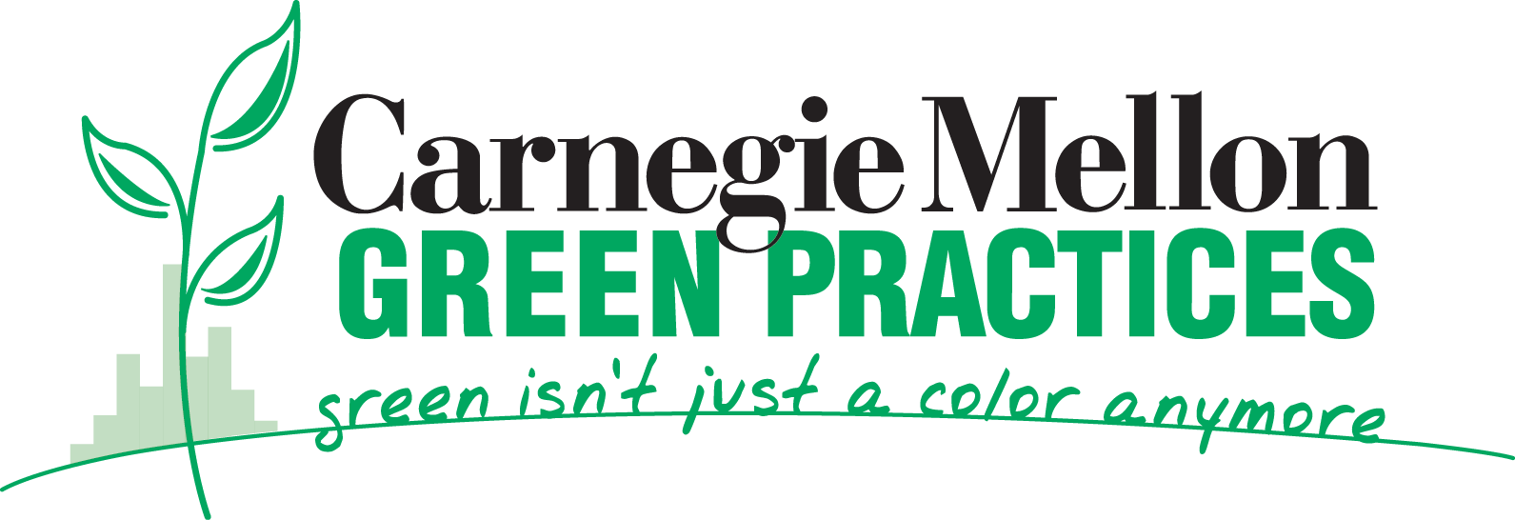

3 Rivers Wet Weather Demonstration Project March 7, 2006
Grant Final Report

- Technical Report (4-5 pages)

1. Narrative Description of Project (brief answers)

  - What was the project supposed to accomplish?
An educational setting is an excellent place to develop and apply sustainable design concepts as it is itself an agent of change and experiment. The Living Roof: Community Supported Design for a Sustainable Future (hereafter referred to as The Living Roof) addresses this idea and takes advantage of the multi-disciplinary opportunities unique to Carnegie Mellon University. What makes us unique are the strengths of departments involved in this project, (student designers, architects, engineers, and artists) and Carnegie Mellon's multi-disciplinary approach to environmental education. Hamerschlag Hall was identified by Facilities Management Services as a prime location for the installation of a 4100sf. living roof demonstration project. Hamerschlag Hall is the signature building for Carnegie Mellon. This particular location is accessible and invites participation for all members of the campus community and beyond.

Research in ‘green practices’ is beginning to saturate the campus from diverse perspectives; students, faculty and staff are making decisions with the environment in mind; and environmental education is a part of many students’ experience in and out of the classroom. This Living Roof project addresses all of these issues in an engaging learning experience for the campus and the regional community. This project will be used as an educational and outreach project and demonstration site to promote sustainable use of natural resources, ground level ozone mitigation, enhancement of biological diversity and other benefits of green roofs. Key benefits are;
• reducing storm water runoff substantially,
• reducing heating and cooling energy costs by 20-30%,
• reducing greenhouse gas (GHG) emissions,
• reducing the urban heat island effect,
• promoting diverse vegetation by more effective use of rain water
• engaging student participation with environmental education and research, and
• building partnerships within the community.

Many of these benefits will be measured and modeled as the project moves forward.

  - What you actually did and how it differs from your plan?
The south roof of Hamerschlag Hall was in need of replacement. Instead of a traditional ballasted roof, Facilities Management Services, with inspiration from an environmental student group, technical support from several academic units, as well as financial resources from the PA Dept of Environmental Protection and the 3 Rivers Wet Weather Demonstration Program, decided to construct a living roof. In the spring of 2002 the students began discussions with Facilities to collaborate on the design of the roof. In the spring of 2005, this living roof became a reality.

The living roof project exceeded our expectations due to the collaborative effort made by all of the individuals involved in the project. The awareness and ‘ripple effect’ the project brought to the campus community included the installation of another living roof by Facilities Management on Mellon Institute, and two other living roof demonstration projects installed on Doherty Hall by the Art Department. Also, there are plans for living roofs on the future Gates Building and Doherty Hall Phase II project.

The living roof, completed May 2005, is being used in a research study to determine how the roof affects the building and its surroundings. The research team is comprised of faculty and students from Civil and Environmental Engineering (CEE), Art and Architecture.

  - What were your successes and reasons for your success?
Using the campus as a living laboratory for green practices, the green roof design was collaborative between faculty, staff, and students. Using a design/build approach to the project was a good decision that not only saved architectural fees but streamlined the process and allowed the team to become more involved in every piece of the project.
The Departments of Art, Architecture and Civil and Environmental Engineering, as well as student environmental groups, all worked closely with Facilities Management Services to design the green roof for function, research, habitat, and aesthetics. External members included the SW PA Dept of Environmental Protection, the 3 Rivers Wet Weather Demonstration Program, and local contractors. Signifying that the university “practices what it preaches”, it is the intent for living roofs to become a default roofing alternative on new or major renovated buildings on campus.

  - What problems were encountered and how you dealt with them?
The original representatives from the PA DEP and Carnegie Mellon project management changed as well as some of the original students that had started with the concept for the living roof had graduated. These problems were not difficult to work through, as one student was involved with the project from beginning to end and the green roof team members guided the process during the changes.

During demolition an unexpected layer of concrete was found on a portion of the decking that needed to be removed. This delayed the project a few days and cost an additional $16,000. Also a safety railing needed to be added for students to work on the roof at an additional cost of $5,000.

  - How your work contributed to solution of original problems?
Relatively little measured data are available to quantify the advantages of a green roof over a conventional roof system. This green roof has been instrumented to allow detailed study of performance with respect to storm water runoff, energy use, and heat island effect. A control roof is similarly instrumented for comparison. Data will be useful to determine how beneficial living roofs are as a storm water management system for Pittsburgh’s overloaded CSO system.

  - What else needs to be done?
Research data collection is being conducted by several Civil and Environmental Engineering graduate students under the direction of Professors Cliff Davidson and Dave Dzombak. Please see attached abstract with details about the research and integrated monitoring equipment.

  - What are your plans for disseminating results of your work?
The green roof demonstration project will be accessible to the public at large. The roof is easily visible from the west campus courtyard. It will be used to promote green roof concepts on campus, in the Pittsburgh region and the state. Carnegie Mellon has a population of 13,000 people, representing several countries from around the world. So far:
- Details about the green roof can be viewed at www.greenpractices.com
- There have been several student projects spun off
- There have been several university classes from this project
- There have been numerous tours for on and off campus groups
- Faculty and students are currently engaged in performance measurements
- Several press releases and newspaper articles, The Greening of America’s Campuses (NYT February 9, 2006)
- Received the 2005 National Roofing Contractors Association Roof of the Year award
and Nominated for 2005 Green Roofs for Healthy Cities and the PA Governor’s Award for Environmental Excellence.
- This project has been included in a recently published Southwestern PA Best
Management Practices primer for storm water management.

  - How well did your spending align with your budget request?

The construction cost for this project is $215,000. This includes support from PA DEP Energy Harvest Grant, 3 River Wet Weather Demonstration Program, and Carnegie Mellon. The DEP Energy Harvest Grant (SW030134EH) provided almost half of the funds to carry out this project. The total cost was close to budget.

2. Summary in 50 words or less suitable for sharing with the public.
“Carnegie Mellon is committed to the study of environmental sciences and the deployment of sustainable practices to bring about a healthier and energy-conscious environment. This focus on environmental sciences and practices is one of the university's strategic priorities that will guide our continued leadership in education, research and contributions to society and industry.”

Environmental education, research, and practice are one of the university’s strategic initiates. The green roof is just one of many environmental practices, such as LEED certified building practices, major purchaser of Pennsylvania NewWind energy, alternative fuels program, rainwater retention system, solar PV installation, and soon a new rainwater garden. To show importance to the university the President, Jared Cohon, recently spoke at a celebration of the green roof completion.

3. Performance Outcome Data (Indicate the amount of energy saved or generated annually as a result of the project)
Many of the benefits are now being measured or modeled as the project moves forward. Quantification of the first-year benefits will be made available to our sponsors as well as posted on the university’s Green Practices web site in 2006.

4. Photographs (Digital are preferred)
Photographed by Suzy Meyer 2005
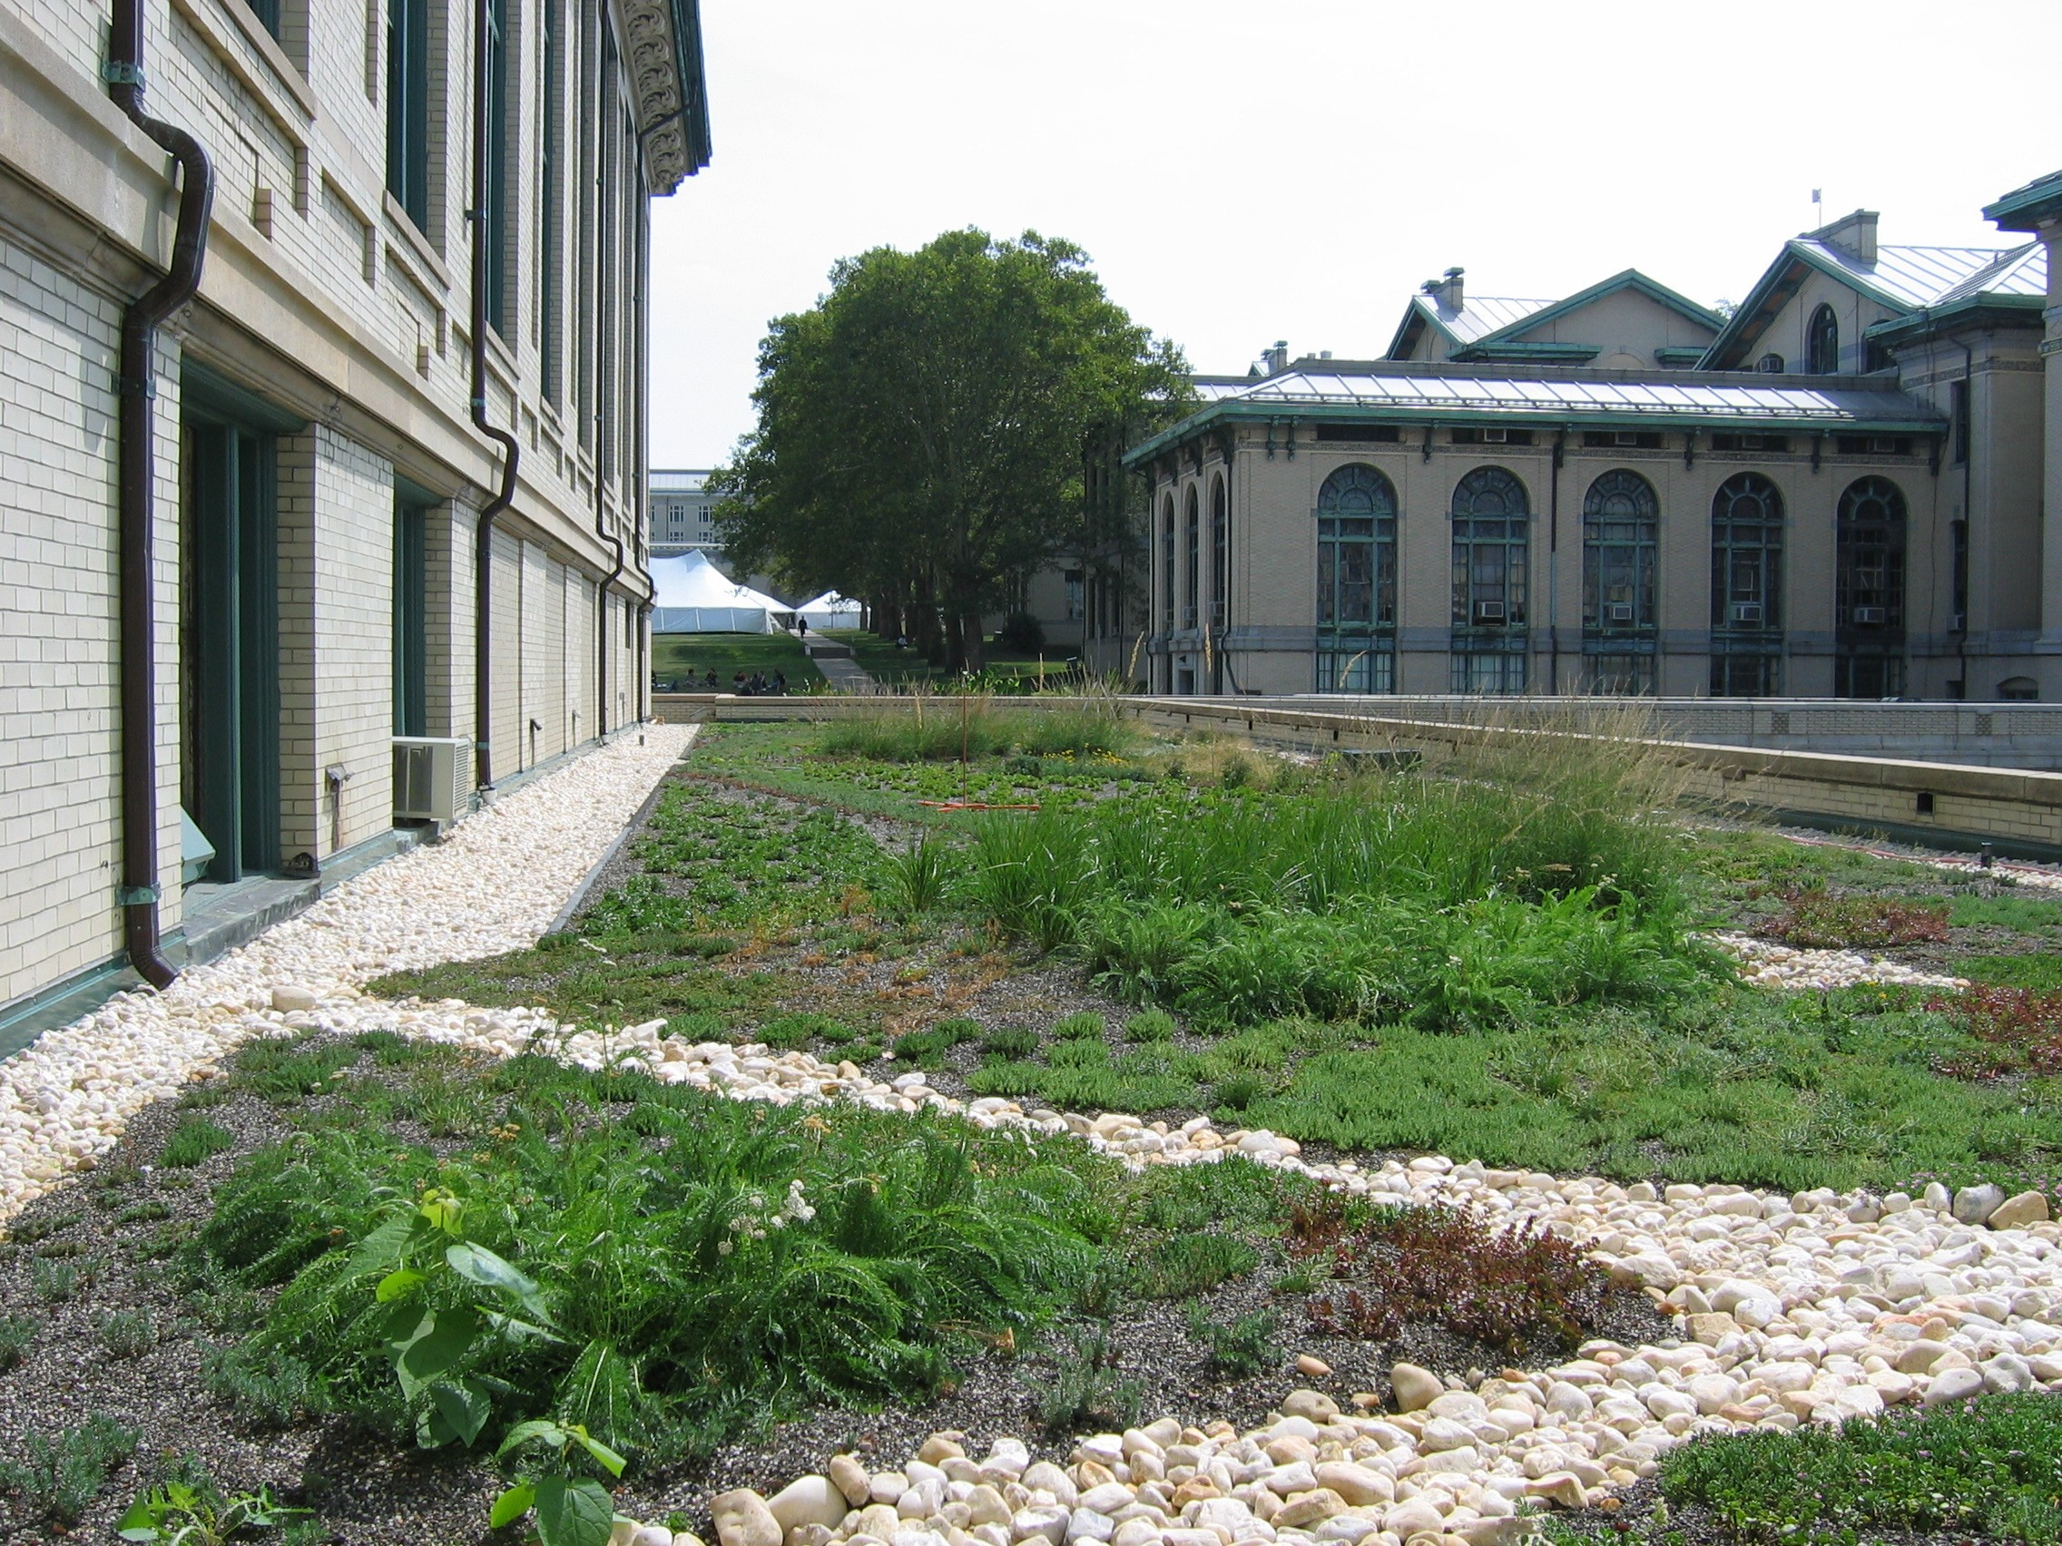

5. Detailed Technical Reports where applicable
Not applicable

6. Operation, Maintenance, and Replacement Plans
Plant Maintenance – The plants were watered one week after planting and then once after a period of three weeks without rain. After 4 months, the watering was reduced to a minimum of a once month during no-rain periods. The goal is to get a ‘dry resistant’ vegetation and no negative impact on the monitoring system. Hand weeding, staking, pruning and trimming is conducted as needed to maintain appearance and plant health. Plants are fertilized with an organic fertilizer every 3 months using a maximum of 5 oz. per 100 square foot only between March and September. Chemical weeding is not allowed.

B. Financial Report – Final Invoices submitted

Barbara Kviz
bk11@andrew.cmu.edu
Environmental Coordinator, Facilities Management
412-268-7858

